**Japneet Kaur(Group -5)**

1. How are inline and block elements different from each other?

Ans 1 - Block-level elements are those which start at new line and take up the full width of the web page

e.g. <div> , <form>, <p>,etc

• Inline element are those that do not start on a new line and only takes up as much width as is required.

e.g. <span>, <i>, <input>, etc.

2. Explain the difference between visibility:hidden and display:none

Ans 2- Visibility:hidden means that the tag used with this is not visible on the page but the space is still allocated on it in the DOM model.

Eg: Hello | <span style=“visibility:hidden;”>I am hidden</span> | Hello

• Display:none means that the tag with which it is used is not visible on the page and unlike visibility:hidden, the space for it is also deleted from the DOM Model.

Eg: Hello | <span style=“display:none;”>I am hidden</span> | Hello

3. Explain the clear and float properties.

The float property is used for positioning and formatting the content on a web page.

e.g. Letting an image float to the left or right of a table

img {

float : right ;

}<p> <img src=“anyimage.jpg”>SomeText </p>

Float can have the following values:

1. Left

2. Right

3. None

4. Inherit

• The clear property specifies what elements can float beside the cleared element and on which side of the web page. It basically clears elements to the direction specified.

4. explain difference between absolute, relative,fixed and static.

Ans 4- • Static : This is the default value. All elements are in the same order as they appear in the document.

• Relative : the element is positioned relative to its normal position

When we set position relative to an element, without adding any other positioning attributes(top, bottom, right, left), nothing will happen. When we add additional positions such like left:20px, the element will move 20px to the right from its normal position. So it moves relative to itself.

Eg: #some_element {

Position : relative ;

Left : 30px;

}

• Absolute : The element is positioned absolutely to it’s first positioned parent.

It allows us to place our element precisely where we want it.

If, there is no positioned parent element, it will be positioned directly related to the HTML element.

Eg: #parent_element {

Position : relative;

Width : 600px;

Height : 600px;

}

#child_element {

Position : absolute;

Right : 40px;

}

• Fixed : The element is positioned related to the browser

5. Write the HTML code to create a table in which there are 4 columns( ID , Employee Name, Designation, Department) and at least 6 rows. Also do some styling to it.

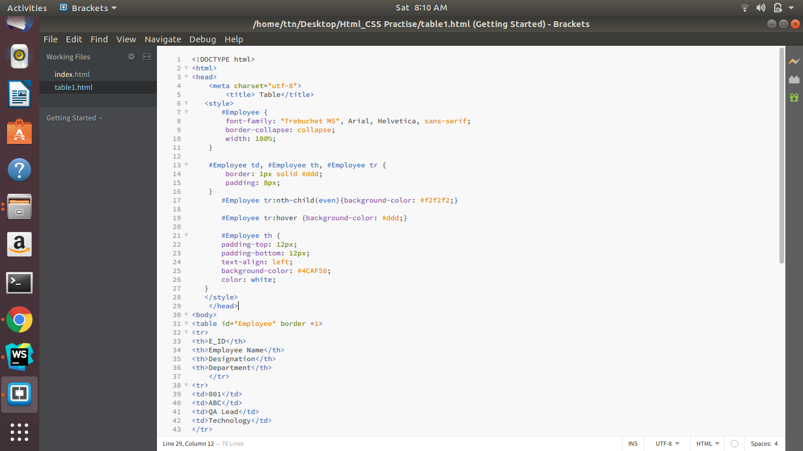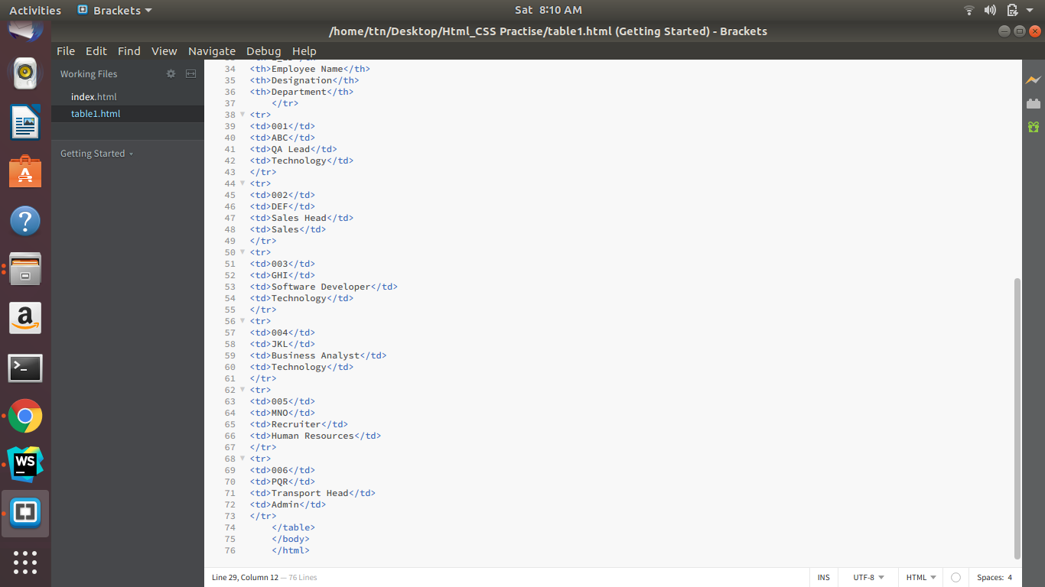

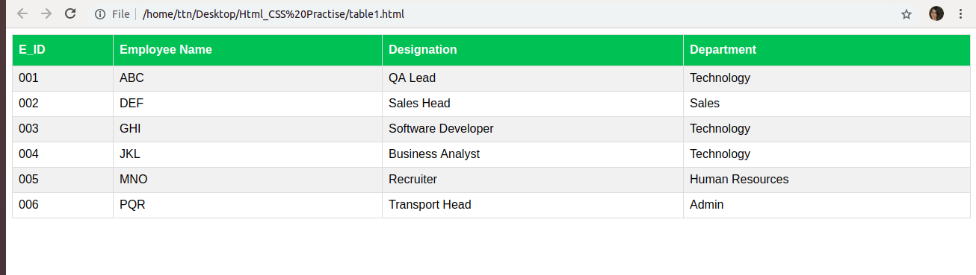

6. Why do we use meta tags?

Ans 6- The <meta> tag provides metadata about the HTML document. Metadata will not be displayed on the page, but will be machine parsable.

The <meta> tag is typically used to specify page description, keywords, author of the document, last modified and other meta attributes. The metadata can be used by the browsers, like how to display content or reload

page.

E.g.

<head>

<meta charset=“UTF-8”>

<meta name=“keywords” content=“HTML, CSS, XML, JavaScript”>

</head>

7. Explain box model.

Ans 7- All HTML elements can be considered as boxes. In CSS, this term is used when talking about design and layout.

• It is essentially a box that wraps around every HTML element.

• It consists of : margins, borders, padding and the content.

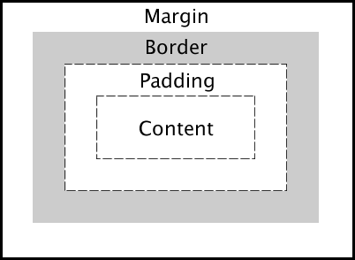

8. What are the different types of CSS Selectors?

Ans 8- • CSS selectors are used to select the content you want to style. They are part of the CSS rule set.

• There are several types of selectors in CSS :

8.1 CSS Element Selector:

<head>

<style>

p{

color : red;

}

</syle>

</head>

<body>

<p>Hello</p>

</body>

8.2 CSS id Selector :

<head>

<style>

#key {

color : red;

}

</syle>

</head>

<body>

<p id=“key”>Hello</p>

</body>

8.3 CSS class selector :

<head>

<style>

.key {

color : red;

}

</syle>

</head>

<body>

<p class=“key”>Hello</p>

</body>

8.4 CSS Universal selector :

<head>

<style>

* {

color : red;

}

</syle>

</head>

<body>

<h1>Big Hello</h1>

<p>Hello</p>

</body>

8.5 CSS group selector :

<head>

<style>

h1, p {

color : red;

}

</syle>

</head>

<body>

<h1>Big Hello</h1>

<p>Hello</p>

<h2>Bye</h2>

</body>

9. Define Doctype.

Ans 9- • The <!DOCTYPE> declaration must be the very first thing in your HTML document, before the <html> tag.

• The <!DOCTYPE> declaration is not an HTML tag; it is an instruction to the web browser about what version of HTML the page is written in.

• In HTML 4.01, the <!DOCTYPE> declaration refers to a DTD, because HTML 4.01 was based on SGML. The DTD specifies the rules for the markup language, so that the browsers render the content correctly.

• HTML5 is not based on SGML, and therefore does not require a reference to a DTD.

10. Explain 5 HTML5 semantic tags.

10.1 <section> (Section)

A section is thematic grouping of content, typically with a heading.

10.2 <article> (Article)

This element specifies independent, self-contained content. An article should make sense on its own, and it should be possible to read it independently from the rest of the web site

10.3 <header> (Article)

It should be used as a container for introductory content at the top generally.

10.4 <footer> (Footer)

It should contain information about it’s containing element. A footer typically

contains the author of the document, copyright information, links to terms of use, etc.

10.5 <nav> (Navigation)

This tag defines a set of navigation links.

11. Create HTML for web-page.jpg

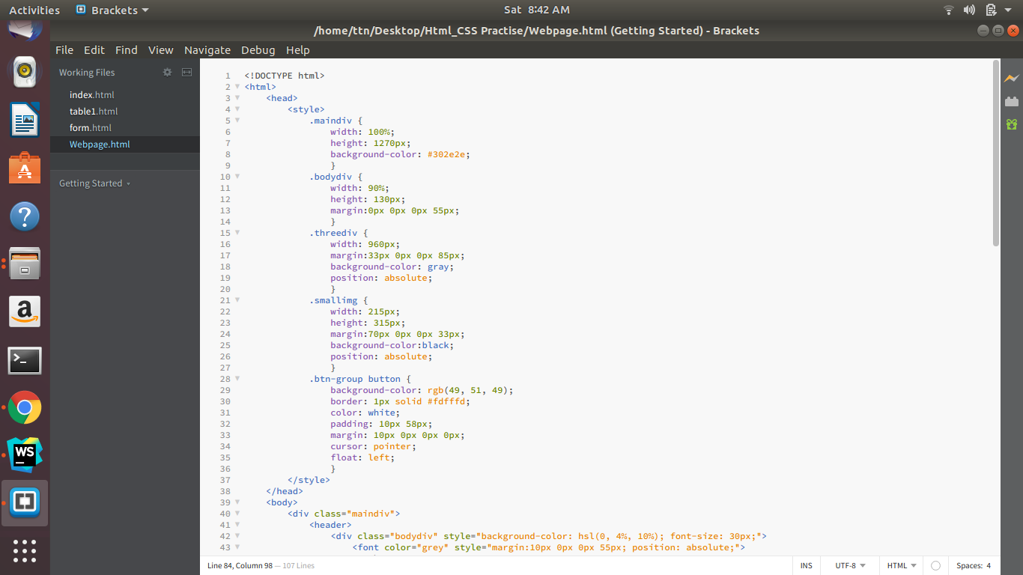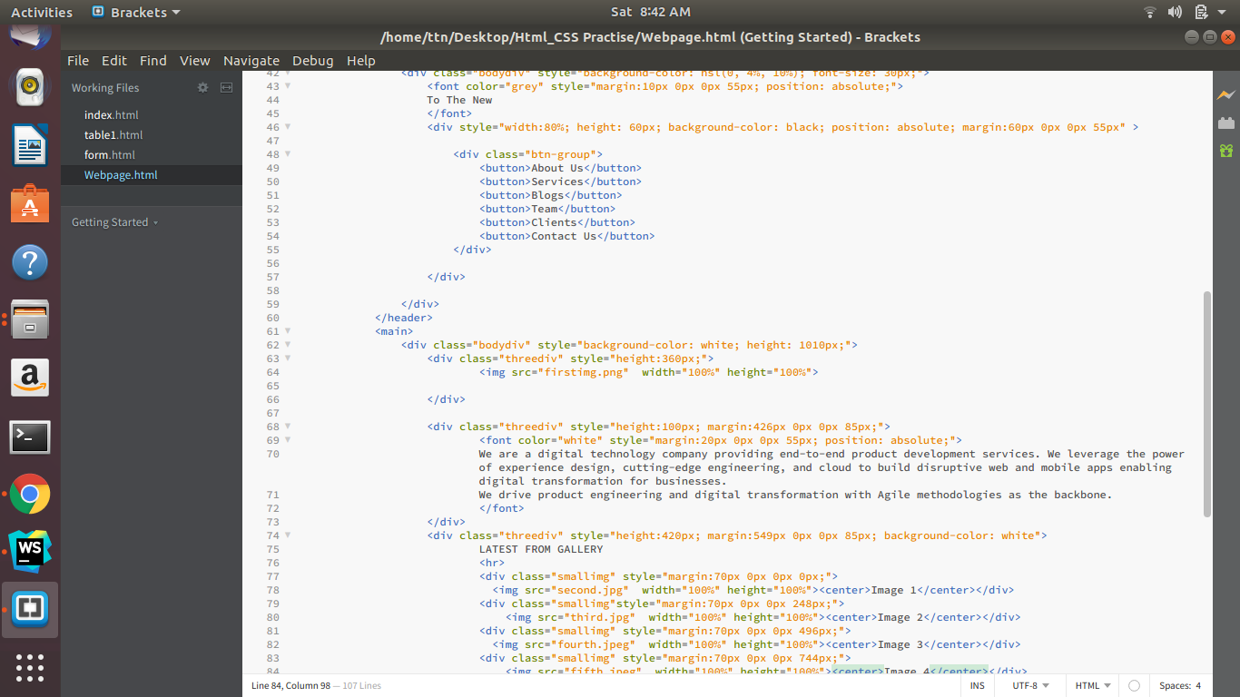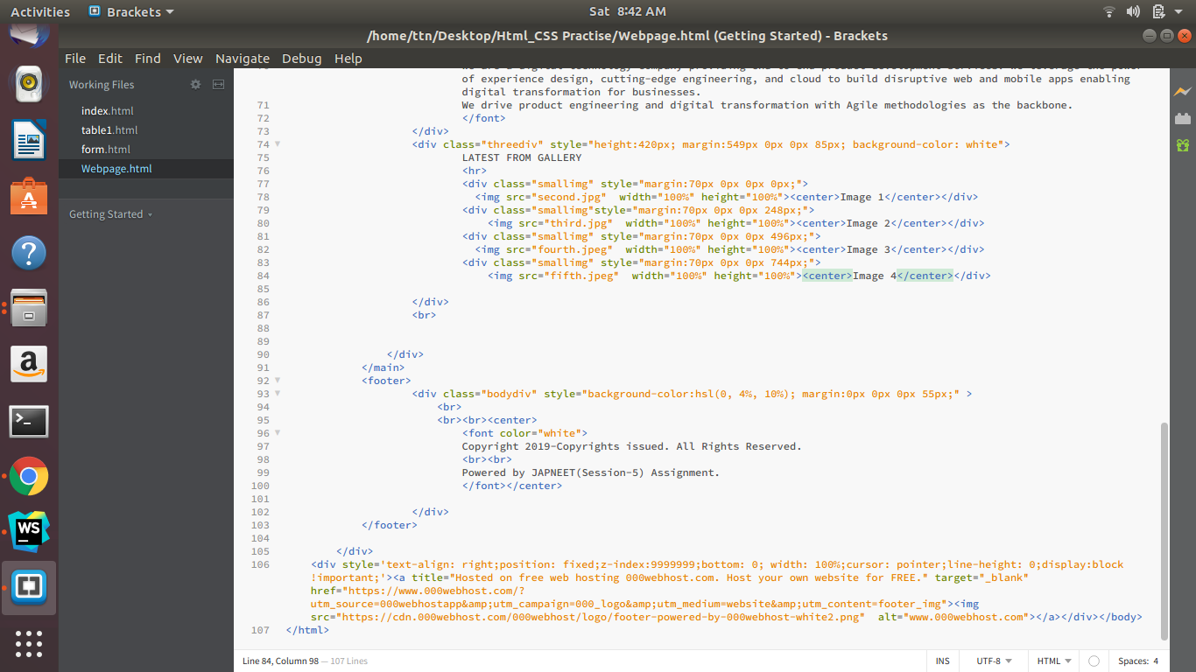

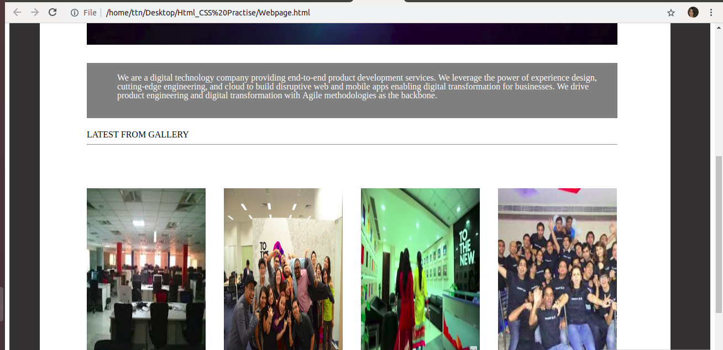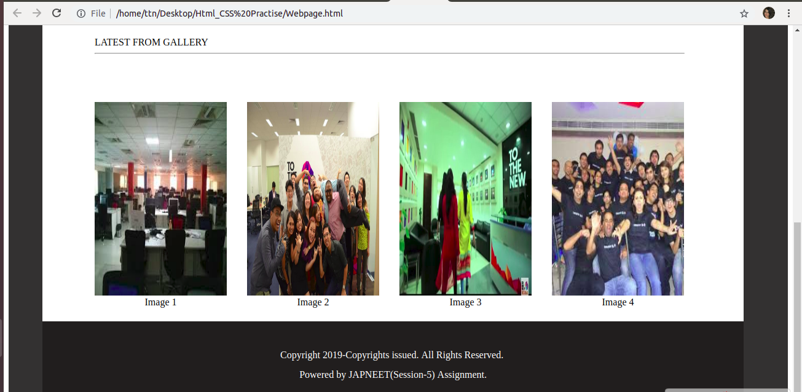

12. Create HTML for form.png

